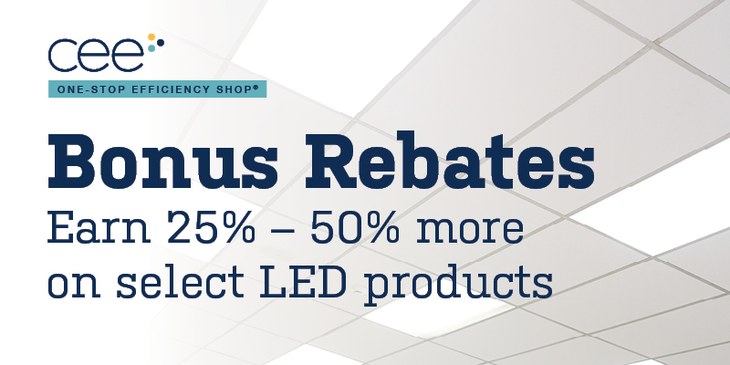
For a limited time, commercial lighting projects that include LED tubes, fixtures, retrofit kits, and screw-ins are eligible for an additional 25% - 50% in rebates when completed through the One-Stop Efficiency Shop, sponsored by Xcel Energy. Don’t miss out on extra savings! Learn more: www.mncee.org/one-stop-lighting-program-bonus-rebates

